# DATABASE SYSTEMS

# Hassaan Akbar Cheema

# Reg no. 174351

# Bscs6c

# Lab 07

**Task: Write Nested SQL expressions for each of the following queries and execute them:**

1. Find the names of all juniors (Level = JR) who are enrolled in a class taught by ‘Ivana Teach’.

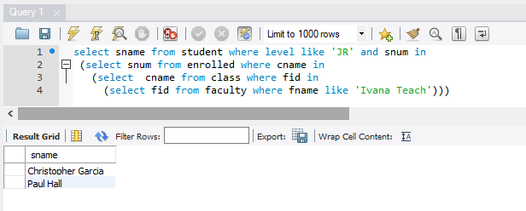

1. Find the names of faculty members that has taught classes only in room R128.

select fname from faculty f, class c

where f.fid = c.fid and c.room = 'R128' and f.fid not in

(select f1.fid from faculty f1, class c1

where f1.fid = c1.fid and c1.room <> 'R128');

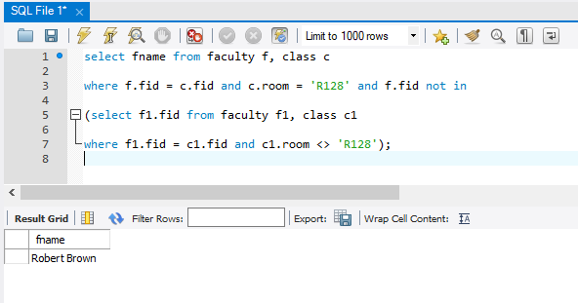

1. Find the names of classes taught by ‘Richard Jackson’ and their times when a class meet there.

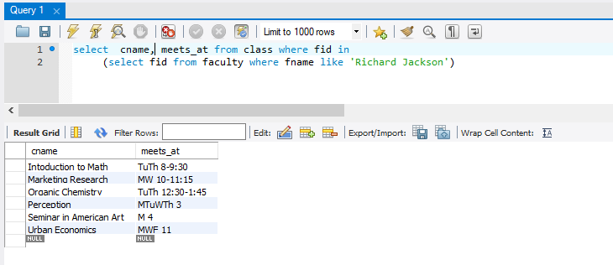

1. Display the names of classes whose students strength is greater than 10.

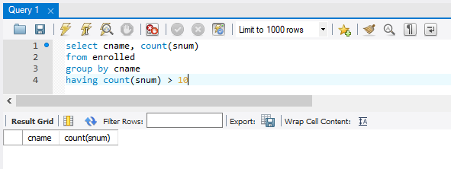

1. Find the names of classes taught by ‘John Williams’ in dept # 68.

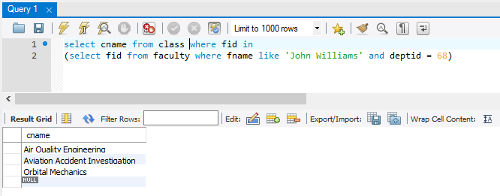

1. For each class taught by ‘John Williams’, retrieve the name and age for students.

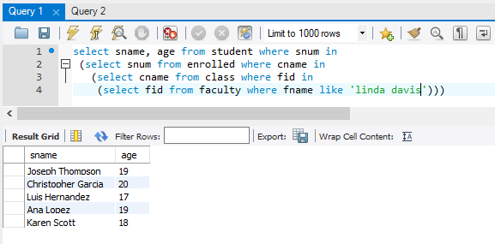

1. Display the faculty names who teach maximum number of classes.

SELECT fname FROM faculty

WHERE fid = (SELECT fid FROM class GROUP BY fid

HAVING COUNT(cname) = (SELECT MAX(counttable.numCount)

FROM (SELECT COUNT(cname) AS numCount

FROM class GROUP BY fid) AS countTable))

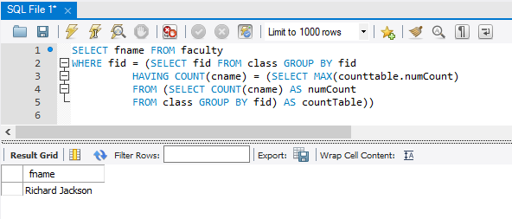

1. Display the name and dept id of faculty members that do not teach to class ‘database

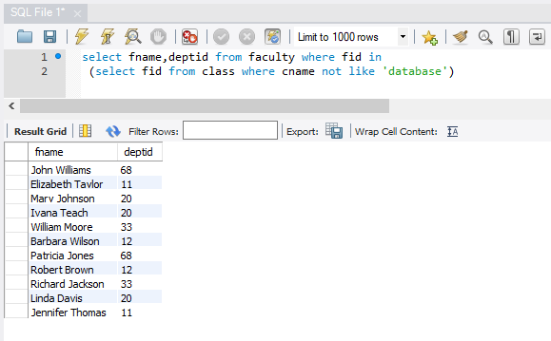

1. Find the name of students enrolled in ‘Data Structures’ and “Database Systems”.

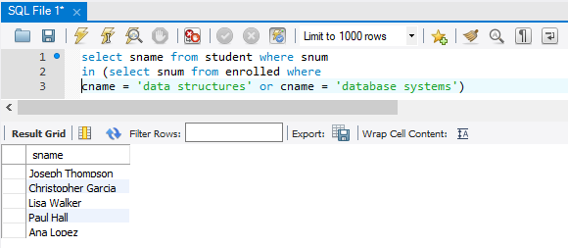

1. List the name of ‘Christopher Garcia’s teachers.

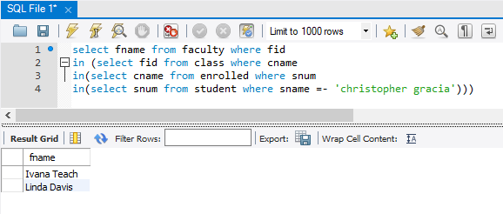

1. Retrieve the snum and sname of students who have taken classes from both ‘Ivana Teach’ and ‘Linda Davis’. (Both with simple and nested queries)

